HARMONY: A Simulation-Based Human-AI Reinforced Multi-Agent Framework for Predictive Maintenance in Resistance Spot Welding

Abstract

Keywords

1. Introduction
1.1 Background and Motivation
1.2 Predictive Maintenance Challenges in Resistance Spot Welding
1.3 Limitations of Current Predictive Maintenance Systems
1.4 Research Gap
1.5 Proposed Solution: The HARMONY Framework
1.6 Contributions of the Paper
1.7 Paper Organisation

2. Related Work
2.1 Multi-Agent Systems in Smart Manufacturing
2.2 Machine Learning for Predictive Maintenance
2.3 Reinforcement Learning for Maintenance Scheduling
2.4 Human-in-the-Loop Predictive Maintenance
2.5 Summary of Research Gap

3. The HARMONY Framework
3.1 Framework Overview
3.2 Agent Roles
3.3 Machine/IoT Agent
3.4 AI Predictive Agent
3.5 Human Operator Agent
3.6 RL Scheduling Agent
3.7 Communication and Feedback Logic

4. Methodology
4.1 Simulation-Based Research Design
4.2 Resistance Spot Welding Case Study
4.3 Dataset Description
4.4 Data Pre-Processing
4.5 XGBoost Model Training
4.6 Human Collaboration Simulation
4.7 PPO Scheduling Environment
4.8 Evaluation Metrics

5. Results
5.1 Machine Learning Model Comparison
5.2 XGBoost Prediction Performance
5.3 PPO Scheduling Performance
5.4 Effect of Human Override Mechanism
5.5 Sensitivity Analysis

6. Discussion
6.1 Interpretation of Findings
6.2 Contribution to Human-Centred Predictive Maintenance
6.3 Practical Implications
6.4 Limitations
6.5 Future Work

7. Conclusion

References
HARMONY: A Simulation-Based Human-AI Reinforced Multi-Agent Framework for Predictive Maintenance in Resistance Spot Welding
Abstract
The integration of predictive maintenance, multi-agent systems, and human-in-the-loop decision-making offers significant potential for improving reliability in smart manufacturing environments. Nevertheless, existing approaches often treat these elements as separate functions, with machine learning models generating predictions, scheduling systems determining maintenance actions, and human operators remaining external to the decision architecture. This paper proposes HARMONY, a Human-AI Reinforced Multi-Agent Network for predictive maintenance in resistance spot welding. The framework combines a Machine/IoT Agent, an XGBoost-based AI Predictive Agent, a Human Operator Agent, and a Proximal Policy Optimisation-based Scheduling Agent to support context-aware maintenance decisions. The framework is evaluated through a simulation-based proof-of-concept using sensor variables associated with resistance spot welding degradation, including electrode force, welding current, electrode tip temperature, ultrasonic inspection score, robot encoder error, and vibration. The predictive layer estimates maintenance urgency, while the scheduling layer selects proactive maintenance actions under operational constraints. Human intervention is selectively triggered under uncertain or ambiguous conditions, allowing contextual refinement before scheduling decisions are finalised. The results indicate that HARMONY provides a feasible architecture for integrating prediction, human judgement, and scheduling in a coordinated multi-agent maintenance system. The study contributes a structured proof-of-concept for human-centred predictive maintenance and establishes a foundation for future industrial validation.
Keywords- Predictive Maintenance; Multi-Agent Systems; Human-in-the-Loop; Reinforcement Learning; XGBoost; Proximal Policy Optimisation; Resistance Spot Welding; Smart Manufacturing; Industry 4.0
1. Introduction
The transition towards Industry 4.0 has reshaped modern manufacturing by integrating cyber-physical systems, industrial sensors, artificial intelligence, and data-driven decision-making into connected production environments. Within this transformation, predictive maintenance has become a central strategy for improving equipment reliability, reducing unplanned downtime, and supporting more efficient maintenance planning. Rather than relying only on fixed maintenance intervals or reactive repair after failure, predictive maintenance uses operational data to identify early signs of degradation and support intervention before faults become disruptive. This is particularly important in high-volume manufacturing systems, where even short interruptions can affect productivity, quality, and cost.
Resistance spot welding is a representative process where predictive maintenance can provide significant value. It is widely used in automotive manufacturing due to its speed, repeatability, and suitability for joining sheet metal components. However, the process is also sensitive to progressive degradation and operational variation. Changes in electrode force, welding current, electrode tip temperature, ultrasonic inspection response, vibration, and robot positioning accuracy can indicate deterioration in process stability or weld quality. In this context, maintenance decisions are not only technical but also operational. A high maintenance urgency score does not automatically determine whether intervention should occur immediately, during a low-load production window, or after a short delay. Therefore, effective predictive maintenance requires both accurate prediction and intelligent scheduling.
Despite the progress made in machine learning-based predictive maintenance, many current systems remain limited by the separation between prediction, decision-making, and human operational judgement. Machine learning models can estimate the likelihood or severity of equipment degradation, but they do not always explain how this information should be translated into a practical maintenance action. Similarly, reinforcement learning and optimisation-based approaches can support scheduling decisions, but fully autonomous decision-making may be difficult to trust in uncertain production environments. Human operators often possess contextual knowledge that is not fully captured by sensors, such as abnormal sounds, visible process irregularities, recent production changes, or maintenance constraints. However, many predictive maintenance systems still position the operator as a passive supervisor rather than as an active decision-making agent.
Multi-Agent Systems offer a useful foundation for addressing this problem because they allow different entities within a manufacturing system to be represented as interacting agents. Machines, predictive models, human operators, and scheduling modules can each be modelled with specific roles, inputs, outputs, and decision responsibilities. However, existing approaches often prioritise technical autonomy and do not fully integrate human judgement into the agent architecture. This creates an important research gap: there is a need for a predictive maintenance framework that connects machine sensing, machine learning-based prediction, human contextual refinement, and proactive maintenance scheduling within a single coordinated architecture.
To address this gap, this paper proposes HARMONY, a Human-AI Reinforced Multi-Agent Network for Predictive Maintenance. HARMONY is a simulation-based framework designed for resistance spot welding environments. It integrates four main agents: a Machine/IoT Agent, an AI Predictive Agent, a Human Operator Agent, and a Reinforcement Learning Scheduling Agent. The Machine/IoT Agent represents the welding process and provides sensor-based condition data. The AI Predictive Agent uses XGBoost to estimate maintenance urgency from process variables. The Human Operator Agent is activated under uncertain or ambiguous conditions, allowing contextual refinement or validation of the AI prediction. The Reinforcement Learning Scheduling Agent uses Proximal Policy Optimisation to select proactive maintenance actions by considering predicted severity, uncertainty, resource availability, production load, and maintenance cost.
The framework is evaluated as a simulation-based proof-of-concept. Resistance spot welding was selected as the target process due to its prevalence in automotive manufacturing, susceptibility to progressive degradation, and suitability for sensor-rich condition monitoring. The simulation uses variables associated with welding process condition and maintenance urgency, including electrode force, welding current, ultrasonic inspection score, electrode tip temperature, robot encoder error, vibration, and a predictive maintenance score. The predictive layer of the framework was developed by comparing multiple machine learning algorithms for maintenance urgency prediction. XGBoost was selected because it provided a strong balance between predictive accuracy, robustness, and computational efficiency. The scheduling layer was implemented using a PPO-based simulation environment, where the agent selects from five maintenance actions while balancing risk reduction, downtime minimisation, and cost control.
This paper makes three main contributions. First, it proposes HARMONY as a human-in-the-loop multi-agent framework for predictive maintenance in resistance spot welding. Second, it integrates an XGBoost-based maintenance urgency prediction layer with an uncertainty-triggered human intervention mechanism. Third, it presents a PPO-based proactive maintenance scheduling layer evaluated through simulation. Together, these contributions demonstrate how predictive modelling, human judgement, and reinforcement learning-based scheduling can be coordinated within a unified multi-agent architecture.
The remainder of this paper is organised as follows. Section 2 reviews related work on multi-agent systems, machine learning for predictive maintenance, reinforcement learning-based scheduling, and human-in-the-loop decision-making. Section 3 presents the HARMONY framework and its agent-based architecture. Section 4 describes the simulation methodology, dataset preparation, XGBoost model training, human collaboration simulation, and PPO scheduling environment. Section 5 presents the simulation results. Section 6 discusses the implications, limitations, and future development of the framework. Section 7 concludes the paper.
2. Related Work

3. The HARMONY Framework
3.1 Framework Overview
This section presents HARMONY, the framework is designed to support predictive maintenance decision-making in resistance spot welding by integrating machine data, predictive modelling, human contextual judgement, and reinforcement learning-based scheduling within a single coordinated architecture.
The central purpose of HARMONY is to move beyond conventional predictive maintenance systems that only generate fault or degradation predictions. In industrial environments, prediction alone is not sufficient. A maintenance urgency score must be translated into a practical decision, such as whether to intervene immediately, postpone maintenance, or schedule it during a low-production window. This decision depends not only on sensor data and model output, but also on production load, resource availability, maintenance cost, and human operational knowledge.
HARMONY addresses this challenge through a multi-agent structure composed of four main agents: the Machine/IoT Agent, the AI Predictive Agent, the Human Operator Agent, and the Reinforcement Learning Scheduling Agent. Each agent performs a specific function within the maintenance decision process, while communication between agents enables coordinated and adaptive decision-making. The framework is designed as a simulation-based proof-of-concept for resistance spot welding, with the intention of providing a foundation for future physical deployment in smart manufacturing environments.
The framework follows a sequential but adaptive logic. First, sensor data from the welding process is collected and pre-processed by the Machine/IoT Agent. This information is then passed to the AI Predictive Agent, which estimates maintenance urgency using an XGBoost-based prediction model. If the predicted condition is uncertain or operationally ambiguous, the Human Operator Agent is activated to review, validate, or refine the prediction. Finally, the Reinforcement Learning Scheduling Agent uses Proximal Policy Optimisation to select an appropriate maintenance action based on the predicted severity, uncertainty level, production context, and resource constraints. The outcome of this decision is then fed back into the system to support continuous improvement.

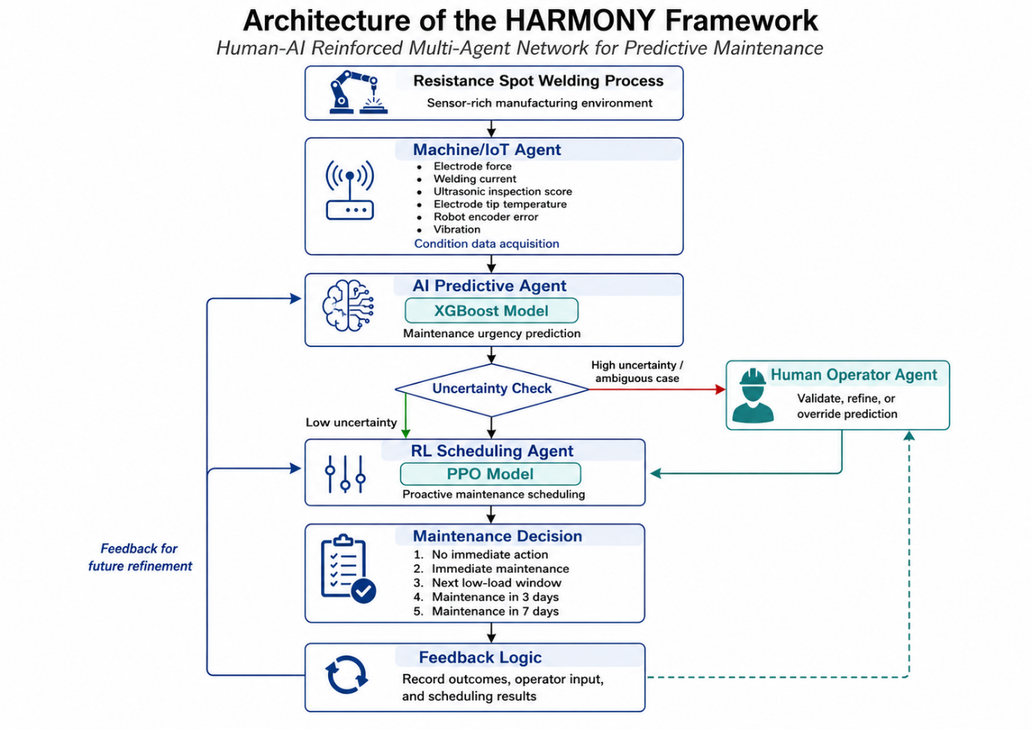
Figure 1. Architecture of the HARMONY framework, showing the interaction between machine sensing, XGBoost-based maintenance urgency prediction, uncertainty-triggered human intervention, PPO-based maintenance scheduling, and feedback logic.
3.2 Agent Roles
The HARMONY framework is structured around the principle that predictive maintenance should be treated as a coordinated decision-making process rather than a single prediction task. Each agent contributes a different form of intelligence to the system. The Machine/IoT Agent provides data-based awareness of the physical process. The AI Predictive Agent transforms sensor information into a maintenance urgency estimate. The Human Operator Agent contributes contextual judgement when the system encounters uncertain or ambiguous conditions. The Reinforcement Learning Scheduling Agent converts predictive and contextual information into a maintenance action.
Table 1 summarises the main agents in the HARMONY framework.
Table 1. Agent roles in the HARMONY framework
Agent | Main Role | Input | Output
Machine/IoT Agent | Collects and transfers process condition data from the resistance spot welding system | Sensor readings from the welding process | Pre-processed process condition data
AI Predictive Agent | Estimates maintenance urgency using XGBoost | Process condition data | Maintenance urgency score and severity indication
Human Operator Agent | Reviews uncertain predictions and provides contextual judgement | AI prediction, uncertainty level, operational context | Validation, refinement, or override
RL Scheduling Agent | Selects proactive maintenance action using PPO | Severity, uncertainty, resource availability, production load, cost factor | Maintenance scheduling decision
Feedback Logic | Records decisions and outcomes for future improvement | Maintenance outcomes, overrides, scheduling results | Updated decision information for later cycles

The use of multiple agents allows the framework to separate responsibilities while maintaining coordination. This separation is important because predictive maintenance involves different types of decisions. Some decisions are data-driven, such as estimating degradation from sensor values. Others are operational, such as determining whether the maintenance team is available or whether production can tolerate downtime. Others require human judgement, especially when the sensor data does not fully represent the real condition of the process.
3.3 Machine/IoT Agent
The Machine/IoT Agent represents the resistance spot welding process within the HARMONY framework. Its role is to collect, organise, and transfer sensor-based information that describes the condition of the welding operation. In a physical deployment, this agent would be connected to sensors, controllers, or industrial communication protocols. In the present simulation-based proof-of-concept, the agent represents the data acquisition layer using sensor variables associated with resistance spot welding condition monitoring.
The process variables considered in the framework include electrode force, welding current, ultrasonic inspection score, electrode tip temperature, robot encoder error, and vibration. These variables were selected because they reflect key aspects of welding process stability and potential degradation. For example, changes in electrode force may indicate contact inconsistency or mechanical degradation. Variations in welding current may affect heat generation and weld quality. Increased electrode tip temperature may suggest thermal stress or electrode wear. Robot encoder error may indicate positioning inaccuracies, while vibration can provide information about mechanical irregularity or process disturbance.
The Machine/IoT Agent therefore provides the foundation for the entire decision process. Without reliable sensor input, the predictive and scheduling layers cannot generate meaningful recommendations. In HARMONY, this agent does not make maintenance decisions directly. Instead, it acts as the condition-awareness layer that supplies structured input to the AI Predictive Agent.
3.4 AI Predictive Agent
The AI Predictive Agent is responsible for estimating maintenance urgency from the process condition data supplied by the Machine/IoT Agent. In the proposed framework, this agent uses an XGBoost-based regression model to predict a maintenance urgency score from the selected resistance spot welding variables. XGBoost was selected because it is well suited to structured tabular data, can model non-linear relationships, and provides strong predictive performance while remaining computationally efficient.
The role of the AI Predictive Agent is not simply to classify the machine as healthy or faulty. Instead, it provides a continuous or severity-based indication of maintenance urgency. This is useful because maintenance decisions in production environments are rarely binary. A system may show early signs of degradation without requiring immediate shutdown, or it may show a high-risk condition that requires rapid intervention. By estimating urgency, the AI Predictive Agent provides the scheduling layer with a more flexible basis for decision-making.
The output of this agent includes the predicted maintenance urgency score and, where required, a derived severity level. This information is then passed to the Human Operator Agent and the RL Scheduling Agent. When the prediction is clear and confidence is high, the system can continue towards scheduling with minimal human intervention. When the prediction is uncertain, ambiguous, or operationally sensitive, the Human Operator Agent is activated to review the decision context.
This design avoids treating the predictive model as an unquestioned authority. Instead, the AI Predictive Agent acts as one component within a wider decision architecture. Its prediction informs the maintenance process, but it can be refined through human judgement and translated into action through reinforcement learning-based scheduling.
3.5 Human Operator Agent
The Human Operator Agent is a central element of the HARMONY framework. Its inclusion reflects the principle that human expertise remains valuable in smart manufacturing, particularly when automated systems encounter uncertainty or incomplete contextual information. In many industrial environments, operators can observe signs that may not be captured by sensors, such as abnormal sound, visible electrode wear, unexpected production behaviour, recent process adjustments, or practical maintenance constraints.
In HARMONY, the human operator is not treated as a passive supervisor who only observes system outputs. Instead, the operator is represented as an active agent who can validate, refine, or override the AI Predictive Agent’s recommendation when specific conditions are met. This is important because involving the human in every decision would create unnecessary workload and reduce system efficiency. Therefore, HARMONY uses a selective human-in-the-loop mechanism.
Human intervention is triggered under uncertain or ambiguous conditions. These may include medium-severity predictions, high uncertainty scores, conflicting sensor patterns, or situations where the predicted maintenance action may significantly affect production. When triggered, the Human Operator Agent reviews the AI recommendation and provides contextual input. This input may confirm the model output, adjust the severity level, or influence the scheduling decision.
The purpose of this mechanism is not to replace the AI model with human judgement, but to combine both forms of intelligence. The AI model provides consistency and computational speed, while the human operator provides context, experience, and practical awareness. This creates a more balanced decision process, where predictive maintenance is both data-driven and operationally grounded.
3.6 RL Scheduling Agent
The Reinforcement Learning Scheduling Agent is responsible for converting predictive and contextual information into a proactive maintenance decision. In HARMONY, this agent uses Proximal Policy Optimisation to select maintenance actions within a simulated resistance spot welding maintenance environment.
The scheduling problem is formulated as a sequential decision-making task. At each decision step, the RL Scheduling Agent observes the current system state and selects an action that aims to reduce maintenance risk while controlling downtime and cost. The state includes information such as estimated time-to-failure, predicted severity, resource availability, production load, time since last maintenance, maintenance cost factor, and uncertainty level. These variables allow the agent to consider both technical condition and operational constraints.
The action space consists of five possible maintenance decisions:
Action | Maintenance Decision
0 | Take no immediate action
1 | Schedule immediate maintenance
2 | Schedule maintenance during the next low-load production window
3 | Schedule maintenance in three days
4 | Schedule maintenance in seven days

This structure reflects the practical nature of industrial maintenance. Not every predicted risk requires immediate shutdown, and not every maintenance action can be delayed without consequence. The RL Scheduling Agent learns to balance competing objectives, including risk reduction, downtime minimisation, and maintenance cost control.
PPO is used because it offers stable policy learning and is suitable for environments where decisions must be updated through repeated interaction with simulated operational conditions. In this framework, the PPO agent does not operate in isolation. Its decision is informed by the AI Predictive Agent and, where applicable, by the Human Operator Agent. This allows the scheduling process to combine predictive analytics, human contextual judgement, and reinforcement learning-based optimisation.
3.7 Communication and Feedback Logic
The effectiveness of HARMONY depends on the communication logic between agents. The framework is designed around a bidirectional flow of information, where data, predictions, human input, and scheduling outcomes are shared across the system. This is important because predictive maintenance is not a one-way process from sensor data to maintenance action. Instead, each decision produces new information that can be used to improve future decision-making.
The communication process begins with the Machine/IoT Agent, which provides sensor-based condition data from the resistance spot welding process. The AI Predictive Agent processes this data and generates a maintenance urgency prediction. The system then evaluates whether the prediction requires human review. If the prediction is stable and confidence is high, it can be passed directly to the RL Scheduling Agent. If the prediction is uncertain, the Human Operator Agent is activated to provide contextual input.
Once the prediction and any human refinement have been finalised, the RL Scheduling Agent selects a maintenance action. This action may involve immediate intervention, delayed intervention, or no immediate maintenance. The selected action and its outcome are recorded by the feedback logic. In a future physical implementation, this feedback would include information such as whether the maintenance action prevented failure, whether downtime was reduced, whether the operator override was useful, and whether the scheduling decision aligned with production requirements.
The general communication sequence is as follows:
- The Machine/IoT Agent collects resistance spot welding condition data.
- The AI Predictive Agent estimates maintenance urgency using XGBoost.
- The uncertainty mechanism determines whether human review is required.
- The Human Operator Agent validates, refines, or overrides the prediction when triggered.
- The RL Scheduling Agent selects a proactive maintenance action using PPO.
- The maintenance decision and outcome are recorded.
- The feedback loop supports future refinement of prediction, scheduling, and human-intervention logic.
This communication structure positions HARMONY as a coordinated human-AI maintenance framework rather than a standalone predictive model. The framework is designed to support more context-aware, transparent, and adaptive maintenance decision-making in smart manufacturing environments.
4. Methodology
4.1 Simulation-Based Research Design
This study adopts a simulation-based research design to evaluate the feasibility of the proposed HARMONY framework before deployment in a physical resistance spot welding environment. The objective of the methodology is not only to test the predictive accuracy of a machine learning model, but also to examine how prediction, human contextual judgement, and reinforcement learning-based scheduling can be integrated within a coordinated multi-agent architecture.
The methodology follows a sequential structure composed of six main stages: system modelling and agent definition, data integration and pre-processing, maintenance urgency prediction, human collaboration simulation, proactive maintenance scheduling, and validation. As shown in Figure X, this structure allows each component of HARMONY to be developed and evaluated systematically. The methodology was designed as a simulation-based workflow covering data handling, model selection, environment design, human-centred decision support, and validation.
Python-based tools were used for the implementation. Machine learning experiments were conducted using standard data science libraries, while the reinforcement learning environment was implemented using Gymnasium and Stable-Baselines3. The simulation-based approach allows controlled testing of the framework under repeatable conditions before future work with live industrial data and real operator interaction.
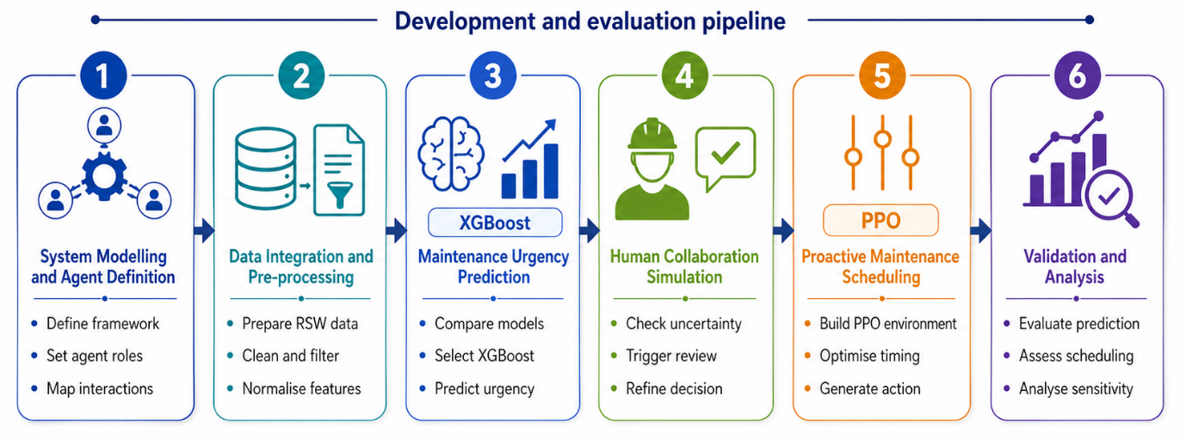
Figure X. Six-stage methodology used to develop and evaluate the HARMONY framework
4.2 Resistance Spot Welding Case Study
Resistance spot welding was selected as the target manufacturing process because it is widely used in automotive production and is sensitive to progressive degradation. The process is suitable for predictive maintenance research because welding quality and process reliability can be affected by changes in electrode condition, welding current, temperature, vibration, and robot positioning accuracy.
In the proposed simulation, the resistance spot welding process is represented by the Machine/IoT Agent, which provides condition-monitoring data to the AI Predictive Agent. This creates a controlled environment in which sensor variables can be converted into a maintenance urgency prediction and subsequently used by the scheduling agent. The existing methodology already identifies resistance spot welding as the selected process because of its industrial relevance, susceptibility to progressive degradation, and availability of sensor-rich data.
The case study is therefore used to demonstrate the feasibility of HARMONY as a human-centred predictive maintenance framework. It does not claim to represent a complete live production deployment at this stage. Instead, it provides a proof-of-concept for connecting machine sensing, XGBoost-based prediction, uncertainty-triggered human intervention, and PPO-based maintenance scheduling.
4.3 Dataset Description
The simulation uses a sensor-rich dataset representative of resistance spot welding conditions. The dataset contains 100,000 samples and includes six input variables associated with welding process condition, alongside a predictive maintenance score used as the target variable. The selected features are designed to reflect both process stability and potential degradation.
The input variables include electrode force, welding current, ultrasonic inspection score, electrode tip temperature, robot encoder error, and vibration. The target variable is the Predictive_Maintenance_Score, which represents the maintenance urgency score on a scale from 0 to 100. The dataset description in the current methodology includes the full statistical summary for each feature, including minimum, maximum, mean, and standard deviation values.
Table 2. Dataset variables used in the HARMONY simulation
Feature / Target | Description | Role in the Framework
Electrode_Force_N | Applied electrode force in newtons | Input feature
Welding_Current_kA | Electrical welding current in kiloamperes | Input feature
Ultrasonic_Inspection_Score | Normalised weld integrity indicator | Input feature
Electrode_Tip_Temp_C | Electrode tip temperature in degrees Celsius | Input feature
Robot_Encoder_Error_mm | Robot positional deviation in millimetres | Input feature
Vibration_Sensor_RMS_ms2 | Root mean square vibration level | Input feature
Predictive_Maintenance_Score | Maintenance urgency score from 0 to 100 | Target variable

The dataset used in this study was treated as a simulation dataset representative of resistance spot welding sensor behaviour. It was used to evaluate the feasibility of the proposed HARMONY framework under controlled conditions before future validation with live industrial welding data.
4.4 Data Pre-Processing
The dataset was pre-processed before model training and simulation. The pre-processing stage aimed to improve data consistency, reduce the effect of abnormal values, and prepare the input variables for both machine learning and reinforcement learning components.
The pre-processing procedure involved four main steps. First, missing values were handled through imputation, using median-based replacement where required. Second, outliers were detected and mitigated using statistical methods such as interquartile range clipping. Third, noise was reduced using filtering methods such as moving averages. Finally, features were normalised to a standard range to support consistent model behaviour. These steps are consistent with the existing methodology, which identifies missing value imputation, outlier mitigation, noise reduction, and feature normalisation as core preparation procedures.
The processed dataset was then divided for model development and testing. For the XGBoost predictive model, 80% of the dataset was used for training and 20% was held out for testing. Standard scaling was applied during model development to ensure consistency across numerical variables. The processed outputs were also used to generate severity and uncertainty values for integration into the PPO scheduling environment.
4.5 XGBoost Model Training for Maintenance Urgency Prediction
The AI Predictive Agent was implemented using an XGBoost regressor. The aim of this model was to estimate the maintenance urgency score from the resistance spot welding process variables. XGBoost was selected because it is suitable for structured tabular data, can model non-linear relationships between process variables, and provides a strong balance between prediction accuracy and computational efficiency.
Before selecting XGBoost as the final model, 18 machine learning algorithms were evaluated across different model families, including baseline methods, instance-based models, tree-based models, kernel methods, bagging ensembles, boosting ensembles, and neural networks. The evaluation used five-fold cross-validation on the pre-processed dataset and considered R² score, mean absolute error, and computational time. XGBoost was selected because it achieved a strong predictive performance while maintaining acceptable training time.
The final XGBoost model was trained using an 80:20 train-test split. The model used the six resistance spot welding condition variables as inputs and the predictive maintenance score as the target variable. The key hyperparameters used for the XGBoost regressor are summarised in Table 3.
Table 3. XGBoost hyperparameters used for maintenance urgency prediction
Parameter | Value | Description
Objective | reg:squarederror | Regression objective
N_estimators | 500 | Number of boosting rounds
Learning_rate | 0.05 | Step size shrinkage
Max_depth | 6 | Maximum tree depth
Subsample | 0.8 | Subsample ratio of training instances
Colsample_bytree | 0.8 | Subsample ratio of columns
Random_state | 42 | Reproducibility setting

The final model was evaluated using mean squared error, mean absolute error, and coefficient of determination. In the current experimental results, the trained XGBoost model achieved MSE = 6.24, MAE = 1.68, and R² = 0.9953 on the test set. These values will be reported in the results section, while this methodology section focuses on how the model was trained and integrated into the HARMONY architecture.
4.6 Human Collaboration Simulation
The Human Operator Agent was implemented as a simulated uncertainty-triggered intervention mechanism. The purpose of this stage was to represent how human contextual judgement could be introduced into the predictive maintenance process without requiring constant human involvement in every decision.
The system evaluates the prediction generated by the AI Predictive Agent and determines whether human review is required. Human intervention is triggered when the system detects uncertainty or ambiguity. This may occur when the predicted severity is within a medium-risk range, when the uncertainty score is high, or when the simulated decision context suggests that the maintenance action may require operational judgement. The existing methodology describes this stage as a human collaboration simulation in which uncertainty triggers, such as confidence thresholds, enable overrides to refine predictions in ambiguous cases.
The simulated human intervention follows three possible outcomes:
Condition | Simulated Human Response | Output to Scheduling Agent
Prediction is clear and low-risk | No intervention | Original AI prediction passed forward
Prediction is uncertain or medium-risk | Human review triggered | Prediction validated or refined
Prediction is high-risk but operationally sensitive | Human review triggered | Contextual override or confirmation

This mechanism is intentionally selective. It avoids overloading the human operator while preserving human involvement in cases where contextual judgement is most valuable. The refined severity or validation decision is then passed to the PPO scheduling environment as part of the system state.
4.7 PPO-Based Maintenance Scheduling Environment
The RL Scheduling Agent was implemented using Proximal Policy Optimisation within a custom Gymnasium environment. The purpose of this environment was to simulate proactive maintenance scheduling for a single-machine resistance spot welding system. The PPO environment models the scheduling problem as a sequential decision-making task in which the agent selects maintenance actions based on machine condition, predicted severity, resource availability, production load, cost, and uncertainty.
The environment operates across episodes of 100 steps. At each step, the agent observes a seven-dimensional normalised state and selects one of five discrete maintenance actions. The environment described in the current results uses seven continuous state features ranging from 0 to 1: time-to-failure, severity derived from XGBoost predictions, resource availability, production load, time since last maintenance, maintenance cost factor, and uncertainty used to trigger human collaboration.
Table 4. PPO scheduling environment
Component | Description
Environment type | Custom Gymnasium environment for single-machine proactive maintenance
Episode length | 100 steps
State space | Seven normalised continuous features
Action space | Five discrete maintenance scheduling actions
Reward design | Multi-objective reward balancing risk, downtime, and cost
Termination | End of episode or critical failure
Human collaboration | Triggered in uncertain cases

The five scheduling actions are:
Action | Maintenance Scheduling Decision
0 | Take no immediate action
1 | Schedule immediate maintenance
2 | Schedule maintenance during the next low-load production window
3 | Schedule maintenance in three days
4 | Schedule maintenance in seven days

The reward function was designed to balance three competing objectives: reducing failure risk, minimising downtime, and controlling maintenance cost. In the current PPO environment, the reward design uses higher weighting for risk reduction, followed by downtime and cost considerations. This reflects the industrial priority of avoiding failure while still considering operational efficiency.
4.8 PPO Training and Evaluation
The PPO agent was trained using Stable-Baselines3 with a multi-layer perceptron policy network. The training configuration used two hidden layers of 64 units, with tanh activation functions. Training was conducted over 200,000 timesteps to support policy convergence within the multi-objective scheduling environment. The key PPO hyperparameters included a learning rate of 3 × 10⁻⁴, batch size of 64, clip range of 0.2, entropy coefficient of 0.01, and discount factor of 0.99. The model also used 2048 steps per update and generalised advantage estimation with λ = 0.95.
The trained policy was evaluated using deterministic testing across multiple simulation episodes. Deterministic evaluation was used to reduce the influence of exploration noise and provide a more stable assessment of scheduling behaviour. The evaluation considered whether the PPO agent selected appropriate maintenance actions under different combinations of severity, uncertainty, production load, resource availability, and cost factor.
The PPO agent was not evaluated as an isolated optimiser. Instead, it was evaluated as part of the wider HARMONY framework, where scheduling decisions are informed by the XGBoost predictive model and, where required, by the simulated Human Operator Agent.
4.9 Evaluation Metrics
The HARMONY framework was evaluated using metrics associated with the predictive model, the scheduling environment, and the human collaboration mechanism. The evaluation was designed to assess whether the framework can integrate prediction, contextual refinement, and scheduling within one coordinated architecture.
Table 5. Evaluation metrics used in the HARMONY methodology
Framework Component | Evaluation Metrics
XGBoost Predictive Agent | MSE, MAE, R²
Model selection | Cross-validation performance, computational time
Human Operator Agent | Number of triggered interventions, number of overrides, effect of refined decisions
PPO Scheduling Agent | Total reward, failure occurrence, action distribution, maintenance timing
Overall framework | Decision consistency, downtime proxy, cost proxy, robustness under uncertainty

4.10 Reproducibility and Computational Setting
The experiments were designed with reproducibility in mind. The implementation used Python-based tools for data handling, machine learning, reinforcement learning, and visualisation. The existing experimental documentation states that the workflow includes data pre-processing, XGBoost training, PPO environment development, processed datasets, trained models, and simulation logs.
A fixed random seed was used where applicable to support repeatability. The experimental setup used standard computing hardware, making the proof-of-concept suitable for replication without specialist industrial computing infrastructure. In the final paper, the repository link should be inserted only once the code and data files are fully organised and anonymised if needed.
5. Results
5.1 Machine Learning Model Comparison
The first stage of the evaluation focused on selecting a suitable predictive model for the AI Predictive Agent within the HARMONY framework. The objective was to identify a model capable of estimating the predictive maintenance urgency score from the resistance spot welding condition variables while maintaining computational efficiency for future real-time or near-real-time implementation.
A total of 18 machine learning models were evaluated across different model families, including baseline models, instance-based methods, tree-based models, kernel-based methods, ensemble models, boosting methods, and neural network models. The models were compared using five-fold cross-validation on the pre-processed dataset. The evaluation considered predictive performance, stability, mean absolute error, and computational time.
The results showed that boosting-based and neural network models achieved the strongest predictive performance. Among the evaluated models, XGBoost provided the most suitable balance between accuracy, error reduction, stability, and training efficiency. Although the simple MLP model achieved a slightly higher mean accuracy, XGBoost achieved a lower estimated MAE and required substantially less computational time. This made XGBoost the preferred model for integration into the HARMONY framework.
Table 6. Comparative performance of selected machine learning models
Model | Mean Accuracy | Accuracy Stability | Mean CV Time (s) | MAE
MLP Simple Network | 93.69% | 0.0003 | 26.91 | 1.92
XGBoost Fast | 93.62% | 0.0000 | 5.07 | 1.68
Gradient Boosting | 93.61% | 0.0003 | 282.65 | 1.85
Random Forest Accurate | 93.58% | 0.0004 | 29.00 | 2.01
LightGBM Fast | 93.53% | 0.0008 | 7.91 | 1.78
Decision Tree Pruned | 93.20% | 0.0005 | 0.69 | 2.45
Gaussian Naive Bayes | 67.03% | 0.0001 | 0.65 | 12.50

Comprehensive Performance table:
Model Configuration | Mean Accuracy (%) | Stability (Std Dev) | MAE | Mean CV Time (s)
MLP (Simple Net) | 93.69 | 0.0003 | 0.115 | 31.8
XGBoost (Fast) | 93.62 | 0.0002 | 0.116 | 4.17
Gradient Boosting (Scikit) | 93.61 | 0.0003 | 0.117 | 228.79
Random Forest (Accurate) | 93.58 | 0.0004 | 0.117 | 18.18
LightGBM (Fast) | 93.54 | 0.0003 | 0.118 | 5.39
MLP (Deeper Net) | 93.53 | 0.0005 | 0.118 | 16.02
XGBoost (Accurate) | 93.52 | 0.0005 | 0.118 | 9.73
LightGBM (Accurate) | 93.49 | 0.0003 | 0.119 | 13.06
Decision Tree (Pruned) | 93.20 | 0.0005 | 0.123 | 0.6
Random Forest (Fast) | 93.13 | 0.0002 | 0.124 | 3.75
Decision Tree (Overfit) | 91.63 | 0.0005 | 0.152 | 0.8
SVM (RBF Kernel, C=1) | 91.19 | 0.0027 | 0.16 | 3.47
KNN (K=15, Smooth) | 90.11 | 0.0003 | 0.174 | 1.56
KNN (K=3, Sensitive) | 88.52 | 0.0005 | 0.201 | 1.12
SVM (Linear Kernel) | 85.72 | 0.0045 | 0.247 | 2.11
Logistic Regression (Low Reg) | 85.12 | 0.0001 | 0.257 | 1.33
Logistic Regression (High Reg) | 85.04 | 0.0002 | 0.258 | 0.88
Gaussian Naive Bayes | 67.03 | 0.0001 | 0.531 | 0.35
Note: All models were evaluated using 5-fold stratified cross-validation. Accuracy Stability represents the standard deviation across folds.
Table 1. Comparative performance of machine learning models for fault detection.

The comparison indicates that XGBoost was particularly effective for the structured resistance spot welding dataset. Its performance suggests that the model was able to capture non-linear relationships between welding process variables and maintenance urgency while avoiding the excessive computational time observed in some alternative models. This supported its selection as the predictive model used by the AI Predictive Agent.
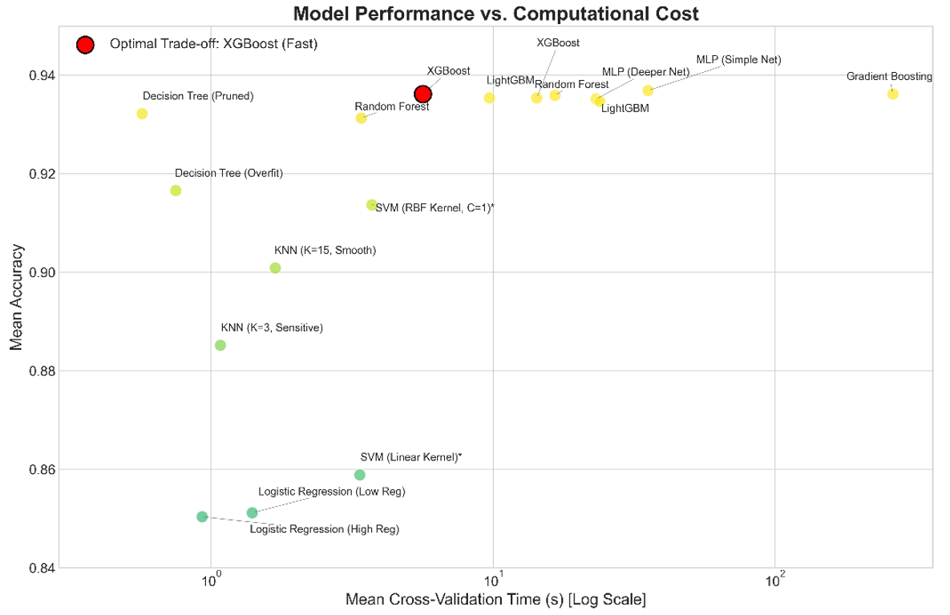
Figure X: Model Accuracy vs. Computational Cost (Log Scale)
Based on this comparison, XGBoost was selected as the predictive model for the AI Predictive Agent. The following subsection presents its test performance and examines the feature importance results to assess whether the model predictions are supported by physically meaningful welding process variables.
5.2 XGBoost Prediction Performance and Feature Importance
After model selection, the final XGBoost regressor was trained using an 80:20 train-test split. The six input variables consisted of electrode force, welding current, ultrasonic inspection score, electrode tip temperature, robot encoder error, and vibration. The target variable was the predictive maintenance score, representing maintenance urgency on a scale from 0 to 100.
The final XGBoost model achieved strong predictive performance on the test set. The model obtained a mean squared error of 6.24, a mean absolute error of 1.68, and an R² score of 0.9953. These results indicate that the model was able to capture the relationship between resistance spot welding process variables and maintenance urgency under the simulated conditions used in this study.
Table 7. XGBoost prediction performance on the test set
Metric | Value
Mean Squared Error | 6.24
Mean Absolute Error | 1.68
R² Score | 0.9953

Figure X presents the relationship between the actual and predicted maintenance urgency scores. The close alignment of the predicted values with the ideal reference line indicates strong agreement between the model predictions and the target values. This supports the suitability of XGBoost as the AI Predictive Agent within the HARMONY framework.

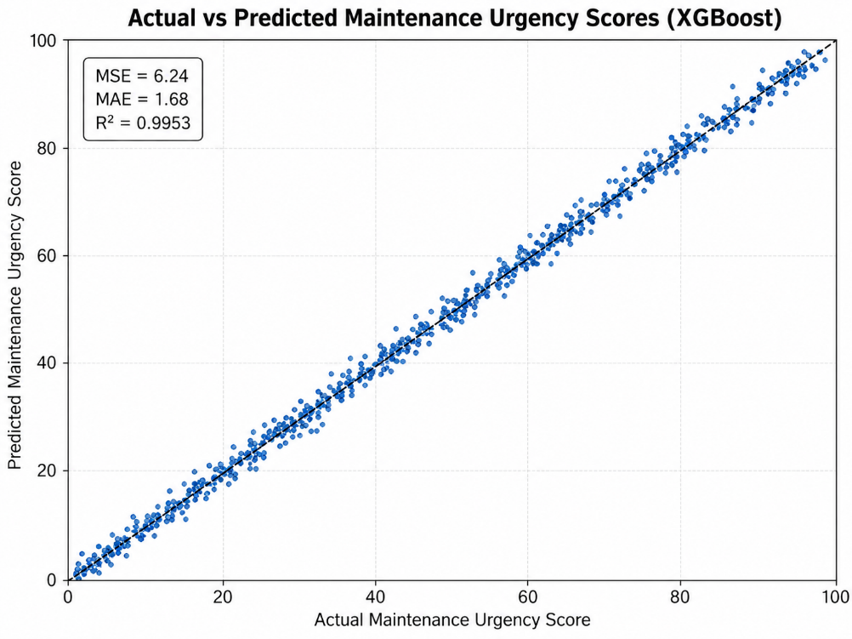
Figure 3. Actual versus predicted maintenance urgency scores using the XGBoost model.
The high R² value indicates that the model explained most of the variation in the maintenance urgency score within the simulation dataset. The low MAE suggests that the predicted maintenance urgency scores were generally close to the target values. This level of performance is suitable for a proof-of-concept framework because the predictive model provides a stable input for the subsequent human intervention and scheduling stages.
Beyond predictive performance, feature importance analysis was conducted to examine which process variables contributed most strongly to the XGBoost model predictions. This step is important because predictive maintenance models should not only achieve high accuracy, but should also provide engineering insight into the physical factors associated with degradation. The feature importance scores are presented in Figure 4.
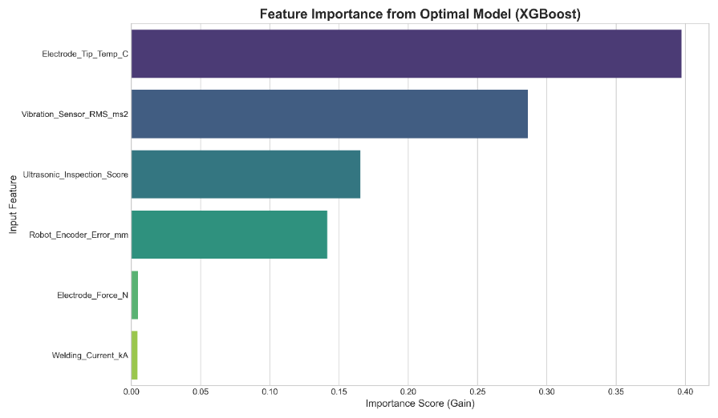
Figure 4. Feature importance scores from the XGBoost maintenance urgency model.
. The analysis shows that Electrode_Tip_Temp_C was the most influential predictor of maintenance urgency. This suggests that thermal behaviour plays a central role in the simulated degradation pattern of the resistance spot welding process. This is physically meaningful, as excessive electrode tip temperature may be associated with electrode wear, heat accumulation, reduced process stability, and changes in weld quality.
The second most influential variable was Vibration_Sensor_RMS_ms2, indicating that vibration also provides important information about the condition of the welding system. Increased vibration may reflect mechanical irregularity, instability in the welding process, or changes in the behaviour of the robotic system. Together, electrode tip temperature and vibration form the primary predictive indicators in the model.
A second group of variables, consisting of Ultrasonic_Inspection_Score and Robot_Encoder_Error_mm, provided additional contextual information. Although these features were less dominant than temperature and vibration, they are still relevant because they may help the model distinguish between different forms of process instability. The ultrasonic inspection score relates to weld integrity, while robot encoder error reflects positional accuracy. These variables therefore support a more complete interpretation of the process condition.
The remaining variables, Electrode_Force_N and Welding_Current_kA, showed lower relative importance. This does not mean that they are irrelevant to resistance spot welding. Rather, within the simulated dataset used in this study, their predictive contribution was weaker or partly captured by the more dominant thermal and vibration-related variables.
These findings provide useful engineering implications. The feature importance analysis suggests that maintenance monitoring in the simulated resistance spot welding system should prioritise electrode tip temperature and vibration. From a practical perspective, this could support the development of tighter alert thresholds for electrode temperature, improved monitoring of vibration signals, or the use of higher-fidelity sensors for early degradation detection. Therefore, the feature importance analysis helps bridge the gap between the machine learning model and practical maintenance decision-making.
However, these findings should be interpreted within the limits of the simulation dataset. The relative importance of each feature may change when the framework is tested using live industrial welding data. Future validation should therefore examine whether electrode tip temperature and vibration remain the dominant predictors under real production conditions.
5.3 PPO Scheduling Performance
The second stage of the evaluation examined the behaviour of the RL Scheduling Agent. The scheduling agent was implemented using Proximal Policy Optimisation within a custom Gymnasium environment. The purpose of this stage was to evaluate whether the predicted maintenance urgency score, together with operational variables such as production load, resource availability, cost factor, and uncertainty, could be translated into proactive maintenance decisions.
The PPO agent selected from five possible maintenance actions: no immediate action, immediate maintenance, scheduling during the next low-load window, scheduling in three days, and scheduling in seven days. The reward function was designed to balance risk reduction, downtime minimisation, and maintenance cost control.
The simulation results showed that the PPO agent was able to learn differentiated scheduling behaviour across changing maintenance conditions. In low-severity and low-uncertainty states, the agent tended to avoid unnecessary intervention. In higher-severity states, the agent selected more proactive maintenance actions, particularly immediate maintenance or scheduling during the next low-load production window. This behaviour suggests that the PPO agent was able to respond to changes in machine condition and operational constraints rather than applying a fixed maintenance rule.
Table 8. PPO maintenance action interpretation
Condition Observed in Simulation | Expected Scheduling Behaviour | Observed Framework Behaviour
Low severity and low uncertainty | Avoid unnecessary maintenance | PPO tended towards no immediate action
Medium severity and moderate uncertainty | Prefer planned maintenance | PPO tended towards delayed or low-load window scheduling
High severity and high risk | Prioritise intervention | PPO tended towards immediate or near-term maintenance
High production load and non-critical severity | Avoid disruptive maintenance | PPO tended towards delayed scheduling
High uncertainty | Trigger human review before scheduling | Human Operator Agent was activated before final scheduling

This behaviour is important because it demonstrates that HARMONY moves beyond simple fault prediction. The framework does not only estimate maintenance urgency; it also supports decision-making about the timing of maintenance intervention.
For the final paper, we should add numerical PPO indicators once available. The recommended indicators are shown in Table 9.
Table 9. Recommended PPO scheduling results to report
Metric | Value
Mean episode reward | [Insert value]
Standard deviation of episode reward | [Insert value]
Number of critical failures | [Insert value]
Percentage of no-action decisions | [Insert value]
Percentage of immediate maintenance actions | [Insert value]
Percentage of low-load window scheduling actions | [Insert value]
Percentage of delayed maintenance actions | [Insert value]

At this stage, the qualitative scheduling behaviour supports the feasibility of the RL Scheduling Agent. However, a stronger version of the paper should include the numerical distribution of PPO actions across multiple evaluation episodes.
Suggested figure to include here:
Figure 4. Distribution of PPO maintenance scheduling actions across evaluation episodes.
5.4 Effect of the Human Override Mechanism
The third stage of the evaluation examined the role of the Human Operator Agent. In HARMONY, human intervention is not applied continuously. Instead, it is selectively triggered when the system identifies uncertainty or ambiguity in the predictive maintenance decision process. This includes cases where the predicted severity is within a medium-risk range, where uncertainty is high, or where the scheduling decision may require contextual operational judgement.
The simulated human collaboration mechanism allowed the system to validate, refine, or override the output of the AI Predictive Agent before the information was passed to the RL Scheduling Agent. The main purpose of this mechanism was to represent how operator knowledge could improve decision reliability in cases where sensor data and model output may not fully capture the operational situation.
The results suggest that the uncertainty-triggered mechanism provides a practical way to include human judgement without overloading the operator. Low-risk and high-confidence cases proceeded without human intervention, while ambiguous cases were routed through the Human Operator Agent. This enabled the framework to maintain automation where appropriate while preserving human oversight where contextual judgement was most valuable.
Table 10. Human intervention logic and observed role in the framework
Decision Condition | Human Operator Agent Activation | Role of Human Input
Low severity, low uncertainty | Not activated | AI prediction passed directly to scheduling
High severity, high confidence | Optional or limited activation | Scheduling prioritised based on risk
Medium severity, high uncertainty | Activated | Prediction validated or refined
Conflicting condition indicators | Activated | Contextual judgement introduced
Operationally sensitive scheduling case | Activated | Maintenance timing refined

This result is significant because it supports the central argument of the HARMONY framework: the operator should not be treated as a passive observer but as an active agent within the predictive maintenance architecture. In practical terms, this means that human judgement is introduced selectively, at the points where it is most likely to improve the quality of the maintenance decision.
For the final version, we should include quantitative indicators of the human override mechanism. These may include the number of triggered interventions, the percentage of predictions reviewed by the Human Operator Agent, and the effect of overrides on scheduling decisions.

Table 11. Recommended human override results to report
Metric | Value
Total number of predictions evaluated | [Insert value]
Number of human interventions triggered | [Insert value]
Percentage of cases requiring human review | [Insert value]
Number of validated predictions | [Insert value]
Number of refined predictions | [Insert value]
Number of overridden predictions | [Insert value]
Change in scheduling decision after human input | [Insert value]

Until these values are finalised, the human collaboration results should be presented as simulation-based evidence of architectural feasibility rather than as proof of operator performance in a real production environment.
5.5 Sensitivity Analysis
A preliminary sensitivity analysis was considered to examine the robustness of the framework under changing uncertainty conditions. The purpose of this analysis was to evaluate whether the HARMONY framework remains stable when the threshold for human intervention changes.
In this analysis, the uncertainty threshold can be varied to represent different levels of human involvement. A lower uncertainty threshold increases the frequency of human intervention, while a higher threshold allows more decisions to be handled autonomously. This trade-off is important because excessive human involvement may slow the system down, while insufficient human involvement may reduce the contextual reliability of the maintenance decision.
Table 12. Recommended uncertainty threshold sensitivity analysis
Uncertainty Threshold | Human Interventions | Critical Failures | Cost Proxy | Downtime Proxy
0.30 | [Insert value] | [Insert value] | [Insert value] | [Insert value]
0.50 | [Insert value] | [Insert value] | [Insert value] | [Insert value]
0.70 | [Insert value] | [Insert value] | [Insert value] | [Insert value]
The expected behaviour is that a low threshold will increase human review and may reduce risky decisions, but could also increase operator workload. A high threshold will reduce human involvement and improve automation, but may allow more uncertain cases to proceed without contextual validation. A moderate threshold is expected to provide a more balanced compromise between autonomy and human-centred reliability.
A second form of sensitivity analysis may be conducted by introducing different levels of noise into the sensor data. This would evaluate whether the XGBoost prediction layer and PPO scheduling layer remain stable under less ideal data conditions.
Table 13. Recommended noise sensitivity analysis
Noise Level | XGBoost MAE | XGBoost R² | PPO Mean Reward | Failure Occurrence
Low | [Insert value] | [Insert value] | [Insert value] | [Insert value]
Medium | [Insert value] | [Insert value] | [Insert value] | [Insert value]
High | [Insert value] | [Insert value] | [Insert value] | [Insert value]

5.6 Summary of Results
The simulation results support the feasibility of the HARMONY framework as a coordinated architecture for human-centred predictive maintenance. The XGBoost model demonstrated strong predictive performance for maintenance urgency estimation, achieving low prediction error and a high R² score on the test set. The PPO scheduling environment showed that maintenance predictions could be translated into differentiated scheduling actions based on severity, uncertainty, production load, resources, and cost. The human collaboration mechanism provided a selective method for involving operator judgement in uncertain or ambiguous cases.
Together, these results demonstrate that HARMONY can integrate predictive modelling, human contextual refinement, and reinforcement learning-based scheduling within a single multi-agent framework. The findings should be interpreted as a simulation-based proof-of-concept rather than a complete industrial validation. Future work should evaluate the framework using live resistance spot welding data, real operator interaction, and deployment through a physical or digital maintenance dashboard.

6. Discussion
6.1 Interpretation of Findings
The results demonstrate the feasibility of the proposed HARMONY framework as a simulation-based approach for integrating predictive modelling, human contextual judgement, and reinforcement learning-based maintenance scheduling within a multi-agent architecture. The main value of the framework is not only that it predicts maintenance urgency, but that it provides a structured mechanism for transforming prediction into action through coordinated agent interaction.
The XGBoost-based AI Predictive Agent showed strong performance in estimating the maintenance urgency score from the resistance spot welding process variables. This suggests that the selected process condition features, including electrode force, welding current, ultrasonic inspection score, electrode tip temperature, robot encoder error, and vibration, provide useful information for representing the health condition of the simulated welding process. The low prediction error and high coefficient of determination indicate that XGBoost was able to model the relationship between the input variables and the maintenance urgency score effectively under controlled simulation conditions.
However, prediction accuracy alone is not sufficient for industrial predictive maintenance. A maintenance urgency score must be interpreted within an operational context. For example, a moderate urgency score may not require immediate intervention if production load is high and the risk remains manageable, whereas the same score may justify earlier intervention if additional uncertainty or contextual evidence suggests deterioration. This is where the HARMONY framework extends beyond conventional machine learning-based predictive maintenance. By integrating a PPO-based scheduling agent, the framework links prediction with maintenance action and allows scheduling decisions to consider risk, downtime, resource availability, production load, and cost.
The PPO Scheduling Agent demonstrated the potential to support differentiated maintenance decisions rather than applying a fixed rule. In low-risk situations, the agent can avoid unnecessary intervention, while in higher-risk states it can prioritise earlier maintenance action. This is important because maintenance scheduling is a sequential decision-making problem rather than a single classification task. The agent must balance immediate risk against longer-term operational consequences. Therefore, the use of reinforcement learning provides a suitable basis for modelling proactive maintenance decisions within dynamic production environments.
The Human Operator Agent represents another important contribution of the framework. The uncertainty-triggered intervention mechanism allows human judgement to be introduced selectively, rather than continuously. This is significant because full human review of every prediction would not be practical in a high-volume manufacturing environment. At the same time, completely autonomous decision-making may fail to capture contextual factors that are visible to operators but not represented in the dataset. The HARMONY framework addresses this by activating human review only when uncertainty, ambiguity, or operational sensitivity is detected. This selective approach supports a balance between automation efficiency and human-centred reliability.
6.2 Contribution to Human-Centred Predictive Maintenance
The main contribution of HARMONY is its treatment of the human operator as an active agent within the predictive maintenance architecture. Many predictive maintenance systems use human operators primarily as recipients of alerts or supervisors of automated systems. In contrast, HARMONY positions the operator as part of the decision loop, with the ability to validate, refine, or override predictions before scheduling decisions are made.
This distinction is important. A conventional predictive maintenance system may produce a risk score or a maintenance alert, but it does not necessarily explain how that information should be interpreted in relation to production constraints. HARMONY addresses this by combining three forms of intelligence. First, machine sensing provides data-based condition awareness. Second, XGBoost provides predictive intelligence by estimating maintenance urgency. Third, human judgement provides contextual intelligence when the system encounters uncertainty. Finally, PPO-based scheduling provides decision intelligence by selecting a maintenance action that balances competing operational objectives.
This layered structure supports a more realistic model of industrial decision-making. In practice, maintenance decisions are rarely made from data alone. They are influenced by shift patterns, spare part availability, operator experience, production pressure, safety considerations, and recent machine behaviour. By introducing a Human Operator Agent, HARMONY acknowledges that predictive maintenance must be technically accurate and operationally meaningful.
The framework also contributes to the wider discussion on trustworthy artificial intelligence in manufacturing. Trust in AI systems is not created only by improving accuracy. It also depends on transparency, controllability, and the ability of human users to intervene when needed. The uncertainty-triggered mechanism supports this by allowing human involvement at critical points in the decision process. This can help reduce the perception that the system is a “black box” and may improve operator acceptance in future industrial implementations.
6.3 Practical Implications
The HARMONY framework has practical implications for resistance spot welding and wider smart manufacturing environments. In resistance spot welding, maintenance decisions are closely linked to quality, productivity, and process stability. Electrode degradation, current variation, excessive temperature, vibration, and positioning errors can affect weld consistency and may lead to rework, production disruption, or quality defects. A framework that connects condition monitoring, maintenance urgency prediction, and proactive scheduling could support more informed maintenance planning.
From an operational perspective, HARMONY could assist maintenance teams by prioritising interventions according to predicted urgency and production context. Instead of presenting operators with isolated alerts, the framework could recommend whether maintenance should be performed immediately, delayed, or scheduled during a low-load window. This would make predictive maintenance more actionable for production environments.
The framework may also support better coordination between production and maintenance functions. In many manufacturing contexts, maintenance decisions are difficult because they compete with production targets. Immediate maintenance may reduce failure risk but disrupt output. Delayed maintenance may preserve short-term productivity but increase the probability of failure. By using PPO to consider multiple decision variables, HARMONY provides a structured way to evaluate these trade-offs.
Another practical implication is the potential development of a future dashboard. The Human Operator Agent could be implemented through an interface that displays maintenance urgency, uncertainty level, suggested action, and the reason for human review. This would allow operators to interact with the system in a controlled and purposeful manner. Such an interface would be especially useful if combined with explainable AI features, allowing users to understand which sensor variables contributed most strongly to the predicted urgency.
6.4 Limitations
Although the results are promising, several limitations must be acknowledged. First, the current study is simulation-based. The framework has not yet been validated using live resistance spot welding data from a physical production line. Therefore, the results should be interpreted as evidence of feasibility rather than proof of industrial effectiveness.
Second, the Human Operator Agent is currently simulated. While this allows the framework to represent uncertainty-triggered human intervention, it does not fully capture the complexity of real operator behaviour. In practice, human decisions may be influenced by experience, workload, confidence in the system, organisational culture, production pressure, and interface design. Future work must therefore include real operator studies to evaluate usability, trust, and decision quality.
Third, the dataset used in the simulation must be clearly positioned as representative of resistance spot welding behaviour. If the dataset is synthetic, public, or adapted, this should be explicitly stated in the final paper. The high performance of the XGBoost model may partly reflect the structure and quality of the simulation dataset. Industrial data is likely to include more noise, missing values, sensor drift, class imbalance, and unexpected operating conditions.
Fourth, the PPO scheduling environment currently represents a simplified maintenance scenario. Although it includes relevant state variables such as severity, resource availability, production load, cost, and uncertainty, real manufacturing environments may involve multiple machines, shared maintenance teams, spare part constraints, shift schedules, quality inspection delays, and competing production priorities. These factors should be included in future extensions of the framework.
Finally, the present results require further baseline comparison. While the current proof-of-concept demonstrates that XGBoost and PPO can be integrated within the HARMONY architecture, future work should compare the full framework against reactive maintenance, fixed-interval preventive maintenance, rule-based predictive maintenance, and autonomous RL scheduling without human intervention. This would provide stronger evidence of the specific value added by the human-in-the-loop multi-agent design.
6.5 Future Work
Future work should focus on strengthening the framework in three main directions: industrial validation, human interaction, and technical extension.
First, the framework should be validated using live resistance spot welding data from an industrial or laboratory environment. This would allow the predictive model to be tested under realistic conditions, including sensor noise, process variation, electrode wear, unexpected disturbances, and production interruptions. Physical validation would also allow the scheduling decisions to be compared with actual maintenance outcomes.
Second, the Human Operator Agent should be implemented through a dashboard and evaluated with real users. Operator studies should examine whether the uncertainty-triggered mechanism improves trust, usability, and decision confidence. These studies should also assess whether operators understand the AI recommendations and whether their interventions improve maintenance scheduling decisions.
Third, the reinforcement learning environment should be extended to represent more complex production systems. Future versions of HARMONY could include multiple machines, multiple maintenance resources, spare part availability, and production sequencing. This would make the scheduling problem more realistic and would allow the framework to be tested as a true multi-agent maintenance coordination system.
Additional technical improvements should also be considered. Explainable AI methods could be added to the XGBoost prediction layer to show which process variables influence the maintenance urgency score. Alternative reinforcement learning algorithms could be compared with PPO to evaluate policy stability and scheduling performance. Sensitivity analysis should also be expanded by testing different uncertainty thresholds, noise levels, reward weights, and human intervention strategies.
Overall, these future developments would help move HARMONY from a simulation-based proof-of-concept towards a deployable human-centred predictive maintenance system for smart manufacturing.

7. Conclusion
This paper proposed HARMONY, a Human-AI Reinforced Multi-Agent Network for Predictive Maintenance in resistance spot welding. The framework was developed to address a key limitation in many predictive maintenance systems: the separation between machine learning-based prediction, human operational judgement, and maintenance scheduling. Rather than treating predictive maintenance as a standalone fault prediction task, HARMONY positions it as a coordinated decision-making process involving machine sensing, AI prediction, selective human intervention, and reinforcement learning-based scheduling.
The proposed framework integrates four main agents. The Machine/IoT Agent provides condition data from the resistance spot welding process. The AI Predictive Agent uses XGBoost to estimate maintenance urgency from sensor-based process variables. The Human Operator Agent is activated under uncertain or ambiguous conditions to validate, refine, or override the prediction. The Reinforcement Learning Scheduling Agent uses Proximal Policy Optimisation to select proactive maintenance actions by considering severity, uncertainty, resource availability, production load, and cost.
A simulation-based proof-of-concept was developed to evaluate the feasibility of the framework. The XGBoost predictive model demonstrated strong performance in estimating maintenance urgency, while the PPO scheduling environment showed how prediction outputs can be translated into differentiated maintenance actions. The uncertainty-triggered human intervention mechanism also demonstrated how operator judgement can be selectively integrated into the maintenance decision process without requiring continuous human involvement.
The main contribution of this work is the development of a human-centred multi-agent architecture that connects prediction, contextual refinement, and scheduling within a single framework. This allows predictive maintenance to move beyond isolated model outputs towards more actionable and operationally meaningful decisions. In this sense, HARMONY provides a structured foundation for future human-AI maintenance systems in smart manufacturing.
The study is limited by its simulation-based validation, simplified single-machine scheduling environment, and simulated representation of human operator behaviour. Future work will focus on validating the framework using live resistance spot welding data, integrating the system into a physical or digital maintenance dashboard, evaluating interaction with real operators, and extending the scheduling environment to multiple machines and more complex production constraints.
Overall, HARMONY demonstrates the potential of combining XGBoost-based maintenance urgency prediction, uncertainty-triggered human judgement, and PPO-based proactive scheduling within a coordinated multi-agent framework. This provides a promising step towards more transparent, adaptive, and human-centred predictive maintenance systems for Industry 4.0 manufacturing environments.

REFERENCES

APENDIX
import pandas as pd
import time
import warnings
import numpy as np
from sklearn.preprocessing import StandardScaler, LabelEncoder
from sklearn.model_selection import cross_val_score, StratifiedKFold, train_test_split
from sklearn.ensemble import RandomForestClassifier, GradientBoostingClassifier
from sklearn.svm import SVC
from sklearn.linear_model import LogisticRegression
from sklearn.neighbors import KNeighborsClassifier
from sklearn.tree import DecisionTreeClassifier
from sklearn.naive_bayes import GaussianNB
from sklearn.neural_network import MLPClassifier
import xgboost as xgb
import lightgbm as lgb
from tqdm import tqdm
# --- SETUP: Suppress warnings for a clean output ---
from sklearn.exceptions import ConvergenceWarning
warnings.filterwarnings("ignore", category=UserWarning)
warnings.filterwarnings("ignore", category=ConvergenceWarning)
# --- 1. Data Loading and Preparation ---
print("--- Loading and Preparing Data for Comprehensive Evaluation ---")
# ... (Data loading remains the same) ...
file_path = 'spot_welding_dataset_100k_adjusted.csv'
try:
df = pd.read_csv(file_path)
except FileNotFoundError:
print(f"Error: Dataset '{file_path}' not found.")
exit()
features = ['Electrode_Force_N', 'Welding_Current_kA', 'Ultrasonic_Inspection_Score', 'Electrode_Tip_Temp_C',
'Robot_Encoder_Error_mm', 'Vibration_Sensor_RMS_ms2']
X = df[features]
scaler = StandardScaler()
X_scaled = scaler.fit_transform(X)
Y_maintenance = df['Predictive_Maintenance_Category']
le_maintenance = LabelEncoder()
Y_encoded = le_maintenance.fit_transform(Y_maintenance)
# --- 2. Function to Generate Experiments for a GIVEN SEED ---
def get_experiments(seed):
# The experiment list remains the same
experiments = [
{"family": "1. Baseline Models", "name": "Logistic Regression (Low Reg)",
"model": LogisticRegression(C=10, max_iter=1000, random_state=seed)},
{"family": "1. Baseline Models", "name": "Logistic Regression (High Reg)",
"model": LogisticRegression(C=0.1, max_iter=1000, random_state=seed)},
{"family": "1. Baseline Models", "name": "Gaussian Naive Bayes", "model": GaussianNB()},
{"family": "2. Instance-Based", "name": "KNN (K=3, Sensitive)",
"model": KNeighborsClassifier(n_neighbors=3, n_jobs=-1)},
{"family": "2. Instance-Based", "name": "KNN (K=15, Smooth)",
"model": KNeighborsClassifier(n_neighbors=15, n_jobs=-1)},
{"family": "3. Tree Models", "name": "Decision Tree (Overfit)",
"model": DecisionTreeClassifier(random_state=seed)},
{"family": "3. Tree Models", "name": "Decision Tree (Pruned)",
"model": DecisionTreeClassifier(max_depth=10, min_samples_leaf=20, random_state=seed)},
{"family": "4. Kernel Methods", "name": "SVM (Linear Kernel)",
"model": SVC(kernel='linear', probability=True, random_state=seed), "use_subset": True},
{"family": "4. Kernel Methods", "name": "SVM (RBF Kernel, C=1)",
"model": SVC(kernel='rbf', C=1, probability=True, random_state=seed), "use_subset": True},
{"family": "5. Bagging Ensemble", "name": "Random Forest (Fast)",
"model": RandomForestClassifier(n_estimators=50, max_depth=10, random_state=seed, n_jobs=-1)},
{"family": "5. Bagging Ensemble", "name": "Random Forest (Accurate)",
"model": RandomForestClassifier(n_estimators=200, max_depth=20, min_samples_leaf=5, random_state=seed,
n_jobs=-1)},
{"family": "6. Boosting Ensemble", "name": "Gradient Boosting (Scikit)",
"model": GradientBoostingClassifier(n_estimators=200, learning_rate=0.1, max_depth=5, random_state=seed)},
{"family": "6. Boosting Ensemble", "name": "XGBoost (Fast)",
"model": xgb.XGBClassifier(n_estimators=150, max_depth=6, learning_rate=0.1, objective='multi:softmax',
num_class=len(le_maintenance.classes_), use_label_encoder=False,
eval_metric='mlogloss', random_state=seed, n_jobs=-1)},
{"family": "6. Boosting Ensemble", "name": "XGBoost (Accurate)",
"model": xgb.XGBClassifier(n_estimators=300, max_depth=8, learning_rate=0.05, objective='multi:softmax',
num_class=len(le_maintenance.classes_), use_label_encoder=False,
eval_metric='mlogloss', random_state=seed, n_jobs=-1)},
{"family": "6. Boosting Ensemble", "name": "LightGBM (Fast)",
"model": lgb.LGBMClassifier(n_estimators=150, learning_rate=0.1, objective='multiclass',
num_class=len(le_maintenance.classes_), random_state=seed, n_jobs=-1)},
{"family": "6. Boosting Ensemble", "name": "LightGBM (Accurate)",
"model": lgb.LGBMClassifier(n_estimators=300, learning_rate=0.05, num_leaves=40, objective='multiclass',
num_class=len(le_maintenance.classes_), random_state=seed, n_jobs=-1)},
{"family": "7. Neural Network", "name": "MLP (Simple Net)",
"model": MLPClassifier(hidden_layer_sizes=(50,), max_iter=500, random_state=seed)},
{"family": "7. Neural Network", "name": "MLP (Deeper Net)",
"model": MLPClassifier(hidden_layer_sizes=(100, 50), max_iter=500, random_state=seed, early_stopping=True)}
]
return experiments
# --- 3. Run Comprehensive Evaluation Across Multiple Seeds ---
all_results = []
num_runs = 5 # Set the number of runs for stability testing
subset_size = 10000
for i in range(num_runs):
run_seed = i * 42
print(f"\n--- Starting Run {i + 1}/{num_runs} with random_state={run_seed} ---\n")
experiments = get_experiments(run_seed)
cv_strategy = StratifiedKFold(n_splits=5, shuffle=True, random_state=run_seed)
X_subset, _, Y_subset, _ = train_test_split(
X_scaled, Y_encoded, train_size=subset_size,
stratify=Y_encoded, random_state=run_seed
)
for experiment in tqdm(experiments, desc=f"Run {i + 1} Evaluation"):
model_name = experiment["name"]
model = experiment["model"]
if experiment.get("use_subset", False):
X_eval, Y_eval = X_subset, Y_subset
eval_name = model_name + f" (on {subset_size // 1000}k subset)"
else:
X_eval, Y_eval = X_scaled, Y_encoded
eval_name = model_name
start_time = time.time()
scores = cross_val_score(model, X_eval, Y_eval, cv=cv_strategy, n_jobs=-1, scoring='accuracy')
total_time = time.time() - start_time
all_results.append({
"Model Configuration": eval_name,
"Accuracy": scores.mean(),
"Time (s)": total_time
})
# --- 4. Aggregate and Display the Final Comprehensive Report ---
print("\n" + "=" * 80)
print("--- FINAL COMPREHENSIVE REPORT: Model Performance, Stability, and Cost ---")
print(f"--- (Aggregated from {num_runs} full runs of 5-fold cross-validation) ---")
print("=" * 80)
results_df = pd.DataFrame(all_results)
# Use groupby and agg to calculate mean and std for BOTH accuracy and time
final_report = results_df.groupby('Model Configuration').agg(
Mean_Accuracy=('Accuracy', 'mean'),
Std_Dev_Accuracy=('Accuracy', 'std'),
Mean_Time_s=('Time (s)', 'mean'),
Std_Dev_Time_s=('Time (s)', 'std')
).reset_index()
# Format the final table for presentation
final_report['Mean Accuracy'] = final_report['Mean_Accuracy'].map('{:.2%}'.format)
final_report['Accuracy Stability (Std Dev)'] = final_report['Std_Dev_Accuracy'].map('{:.4f}'.format)
final_report['Mean CV Time (s)'] = final_report['Mean_Time_s'].map('{:.2f}'.format)
# Sort by the most important metric: Mean Accuracy
final_report = final_report.sort_values(by='Mean_Accuracy', ascending=False)
# Select and rename columns for the final report
report_columns = [
'Model Configuration',
'Mean Accuracy',
'Accuracy Stability (Std Dev)',
'Mean CV Time (s)'
]
print(final_report[report_columns].to_markdown(index=False))

